**Project Planning Phase**

**Project Planning (Product Backlog, Sprint Planning, Stories, Story points)**

|  |  |
| --- | --- |
| Date | 19 Nov 2022 |
| Team ID | PNT2022TMID21718 |
| Project Name | Project – Web Phishing Detection |
| Maximum Marks | 8 Marks |

**Product Backlog, Sprint Schedule and Estimation (4 Marks)**

**Product backlog and sprint schedule:**

|  |  |  |  |  |  |  |
| --- | --- | --- | --- | --- | --- | --- |
| **Sprint** | **Functional**  **Requirement (Epic)** | **User Story Number** | **User Story / Task** | **Story Points** | **Priority** | **Team**  **Members** |
| Sprint-1 | User input | USN-1 | User inputs an URL in the required field to check its validation. | 5 | Medium | Sreejith S |
| Sprint-1 | Website Comparison | USN-2 | Model compares the websites using Blacklist and Whitelist approach. | 10 | High | Syed Anas Ahmad |
| Sprint-1 | Storage | USN-3 | Storing the Blacklisted websites in Database using IBM Cloud. | 15 | High | Yuvan Kumar |
| Sprint-2 | Feature Extraction | USN-4 | After comparison, if none found on comparison then it extract feature using heuristic and visual similarity. | 10 | High | Varun D |
| Sprint-2 | Prediction | USN-5 | Model predicts the URL using Machine learning algorithms such as logistic Regression, MLP. | 10 | Medium | Sreejith S |
| Sprint-2 | Accuracy Test | USN-6 | Selecting the best accurate model and to process further steps. | 15 | High | Yuvan Kumar |
| Sprint-3 | Classifier | USN-7 | Model sends all the output to the classifier and produces the final result. | 5 | Medium | Varun D |
| Sprint-3 | Hosting | USN-8 | Setting Up the Application and hosting in IBM cloud | 10 | Medium | Syed Anas Ahmad |
| Sprint-4 | Announcement | USN-9 | Model then displays whether the website is legal site or a phishing site. | 15 | High | Sreejith S |
| Sprint-4 | Events | USN-10 | This model needs the capability of retrieving and displaying accurate result for a website. | 10 | High | Yuvan Kumar |

**Project Tracker, Velocity & Burndown Chart (4 Marks)**

|  |  |  |  |  |  |  |
| --- | --- | --- | --- | --- | --- | --- |
| **Sprint** | **Total Story Points** | **Duration** | **Sprint Start Date** | **Sprint End Date (Planned)** | **Story Points**  **Completed (as on**  **Planned End Date)** | **Sprint Release Date (Actual)** |
| Sprint-1 | 20 | 6 Days | 24 Oct 2022 | 29 Oct 2022 | 20 | 29 Oct 2022 |
| Sprint-2 | 20 | 6 Days | 31 Oct 2022 | 05 Nov 2022 | 20 | 05 Nov 2022 |
| Sprint-3 | 20 | 6 Days | 07 Nov 2022 | 12 Nov 2022 | 20 | 12 Nov 2022 |
| Sprint-4 | 20 | 6 Days | 14 Nov 2022 | 19 Nov 2022 | 20 | 12 Nov 2022 |

# Velocity:

Imagine we have a 10-day sprint duration, and the velocity of the team is 20 (points per sprint). Let’s calculate the team’s average velocity (AV) per iteration unit (story points per day)

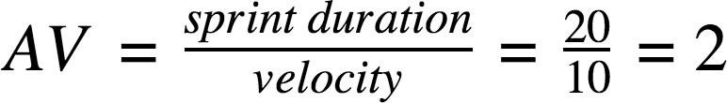

We have a 6-day sprint duration, and the velocity of the team is 20 (points per sprint). So our team’s average velocity (AV) per iteration unit (story points per day)

**AV = (Sprint Duration / Velocity) = 20 /6 = 3.33**

# Burndown Chart:

A burn down chart is a graphical representation of work left to do versus time. It is often used in agile [software development m](https://www.visual-paradigm.com/scrum/what-is-agile-software-development/)ethodologies such as [Scrum.](https://www.visual-paradigm.com/scrum/scrum-in-3-minutes/) However, burn down charts can be applied to any project containing measurable progress over time.

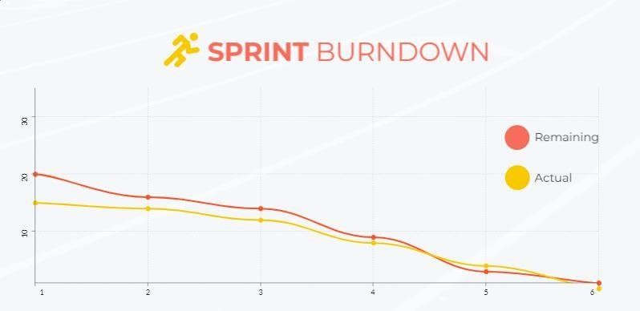

# Reference:

**https:**[**//www.visual-paradigm.com/scrum/scrum-burndown-chart/**](http://www.visual-paradigm.com/scrum/scrum-burndown-chart/) **https://**[**www.visme.co/templates/charts/sprint-burndown-chart-1425285230/**](http://www.visme.co/templates/charts/sprint-burndown-chart-1425285230/)